

A SYNOPSIS OF PROJECT ON

UNICARE Hospital Management System

(BMC-452)
Session 2025-26

Submitted In Partial
Fulfillment of The Requirements for the Award of the Degree of

Master of Computer Applications

By

Sindhraj Singh (2412000140166)

Under the Supervision of Ms. Vandana Kumari



Department of Master of Computer Applications
G.L. Bajaj College of Technology & Management Greater Noida



OBJECTIVE OF THE PROJECT

- The main goal of the project is to create an all-inclusive web-based hospital management solution (known as UNICARE) to automate or simplify every operational process such as registration of patients, appointment scheduling, doctor management, billing, etc.
- The main objective is to build a centralized digital platform that does away with the need for paper records, reduces the amount of manual error, and guarantees fast and precise access to the complete health records of patients by authorized hospital personnel.
- Develop a secure patient registration and profile management module to create an efficient database to hold each patient's medical history, contact information, and visit history
- To install a smart appointment scheduling system which will enable patients to schedule and reschedule appointments and cancel them online and doctors to manage their schedules effectively.
- To create a billing and invoice management module which automatically calculates the cost of treatment, produces itemized bills and has a full history of payments made to each patient.
- To create a role-based access control system such that administrators, doctors, nurses, and patients may only access information pertinent to their different roles to maintain data security and privacy.
- To create meaningful reports and analytics to be used by the hospital administrators to track the patient flow, the work of doctors, revenue, and the overall hospital efficiency.



PROBLEM STATEMENT

Running a hospital or a healthcare facility can be complicated. Many hospitals handle thousands of patients each day; a vast array of patient medical records; several hundred appointments; a large number of doctors, nurses, and administrative staff and a multitude of financial transactions, all at the same time. Many small and medium-sized hospitals use manual or ineffective, outdated software programs to carry out some of these critical functions, causing hospitals to have significant difficulties which in many cases negatively impact on patient care.

Paper medical records are often inaccurate and take a considerable amount of time to maintain, many times resulting in lost or misplaced medical records and potentially increasing the length of time it takes for patients to receive care which can lead to death. In addition, physicians oftentimes do not have an accurate and complete record of a patient’s medical history at the time they are providing care to that patient, which can impede their ability to make informed decisions regarding how to treat that patient. Additionally, scheduling patient appointments manually can lead to hospitals double-booking patient appointments, wait times that are excessive in some clinics, and the unnecessary wasting of physicians’ valuable time.

If the hospitals send out their invoices by hand rather than electronically, that will cause a lot of errors in the billing process. The billing process could create dissatisfaction from the patient and the hospital, and confusion to both the patient and the hospital. In hospitals, there can be many different incidences of communication problems among departments because each department functions independently and cannot work together towards their objectives. There has to be an intelligent solution which would provide a single digital solution, like UNICARE, to the hospital to store and share its entire range of operations and to allow all users the same level of real-time access to their data. By using this type of system, the chances of making mistakes are reduced, and there can be more consistency in each of the operations performed by both the hospital's staff and the patients. If all of the hospitals could use a unified system, they would be able to better coordinate their various functions, as well as provide their patients with improved care; thus, making the hospitals more patient-centred and operationally efficient.



BACKGROUND

  - • The healthcare industry is one along with the highest concentration of data in the world; as a consequence, hospitals provide a huge amount of information daily including patient admission, discharge records, lab reports, prescriptions, imaging tests, and insurance claims. New "best practices" are continuously updating tools for storing and managing all information so that there are no gaps in quality care or safety.
  - For many years, hospitals maintained all their records on paper. While this method provided some means of keeping records historically, there were many issues associated with this traditional system. Paper records were subject to damage, loss or difficulty locating them. In addition, the various parts of the hospital had a difficult time ensuring that all the information across the facility was current and accurate.
  - The introduction of computer systems into hospital administration in the late 20th century dramatically transformed how healthcare operated by significantly changing hospital management processes. In the beginning, computer systems were utilized primarily for the purpose of registering patients and billing patients for care received. However, as these systems evolved over time, they eventually evolved into completely functional Hospital Management Systems (HMS). HMS support all functions within the hospital including patient care, financial operations and administrative functions of the hospital, thereby providing hospitals with a means of operation that supports their mission and objectives. Furthermore, HMS enhance the quality of care provided to the patients of the hospital and promote the efficient conduct of the daily operations of the facility.
  - These days, hospital management systems are really powerful tools. They've gotten a lot better with the internet, cloud computing, and mobile devices. Now, doctors and staff can get to important information in real time from almost anywhere. They can even use video calls to talk to patients remotely, which is called telemedicine. Some systems also use artificial intelligence to help doctors figure out what's wrong with patients. And patients can use special websites or apps to make appointments and keep track of their own health, which is pretty convenient.
  - Even with all the progress made, a lot of hospitals in India, especially in smaller cities, still use old-fashioned or manual ways of doing things. The UNICARE Hospital Management System is meant to fill this gap by offering a digital solution that is affordable, easy to use, and fully integrated, specifically designed for the needs of modern healthcare in India.


TOOLS and PLATFORM

1. System Requirements
- CPU -> Minimum Intel Core i5 or better
- Memory -> Min 8GB RAM (Recommended: 16GB)
- Drive -> 512GB SSD or larger
- Internet -> Reliable Internet access (both LAN and Wi-Fi) is needed

2. Software Requirements
- User Interface -> Must develop using any combination of HTML5, CSS3 (using Tailwind CSS) and JavaScript (ES6)
- Backend -> Application should be written using backend run time, e.g., Node.js using Express.js.
- Storage -> MongoDB used for data storage utilizing the Mongoose object modeling library.
- Web Server -> Node.js (Express Web Server)
- Code Editor -> Visual Studio Code
- Operating System -> Windows 10 or Windows 11
- Authentication -> All users are required to login into their unique authenticated account. Therefore, "JSON Web Token" based "Role Based Access Control" will be used to provide authenticated access to the back-end for users of all roles- administrator, doctor, patient, nurse.
- API tester -> Postman
- Version Control -> Git/Github



ER Diagram

An Entity-Relationship (ER) diagram is the easiest way of displaying a database structure and the various components within it. These diagrams often allow us to visualize the various elements of a system, such as objects found in the world (which we call entities), the specifics about those individual entities (also called attributes), and how the entities are associated. These diagrams are mainly used in the database design phase to ensure all relationships and components of the entity are defined prior to implementation.

In the UNICARE Hospital Management System there are several examples of significant entities. Some of these examples include; Patient, Doctor, Appointment, Department, Ward, Billing, Medicine, and Administrator. These entities each have their own set of individual data. A patient for instance has an ID, name, age, gender, phone number, email address, and medical history. Each of the doctors on the other hand has an ID, name, area of expertise or specialization, a department they work in, phone number and/or other contact details, and hours they are available to see patients.

With regards to how the entities relate to one another; once a patient schedules an appointment with a doctor, they should then be seen and treated by that doctor once the appointment is scheduled. As a result of appointments with a doctor, a patient may then be billed for the services rendered. The patient could then admit to a ward for further care based on the diagnosis given by the doctor. An administrator keeps track of all these different relationships and makes sure the system runs smoothly.
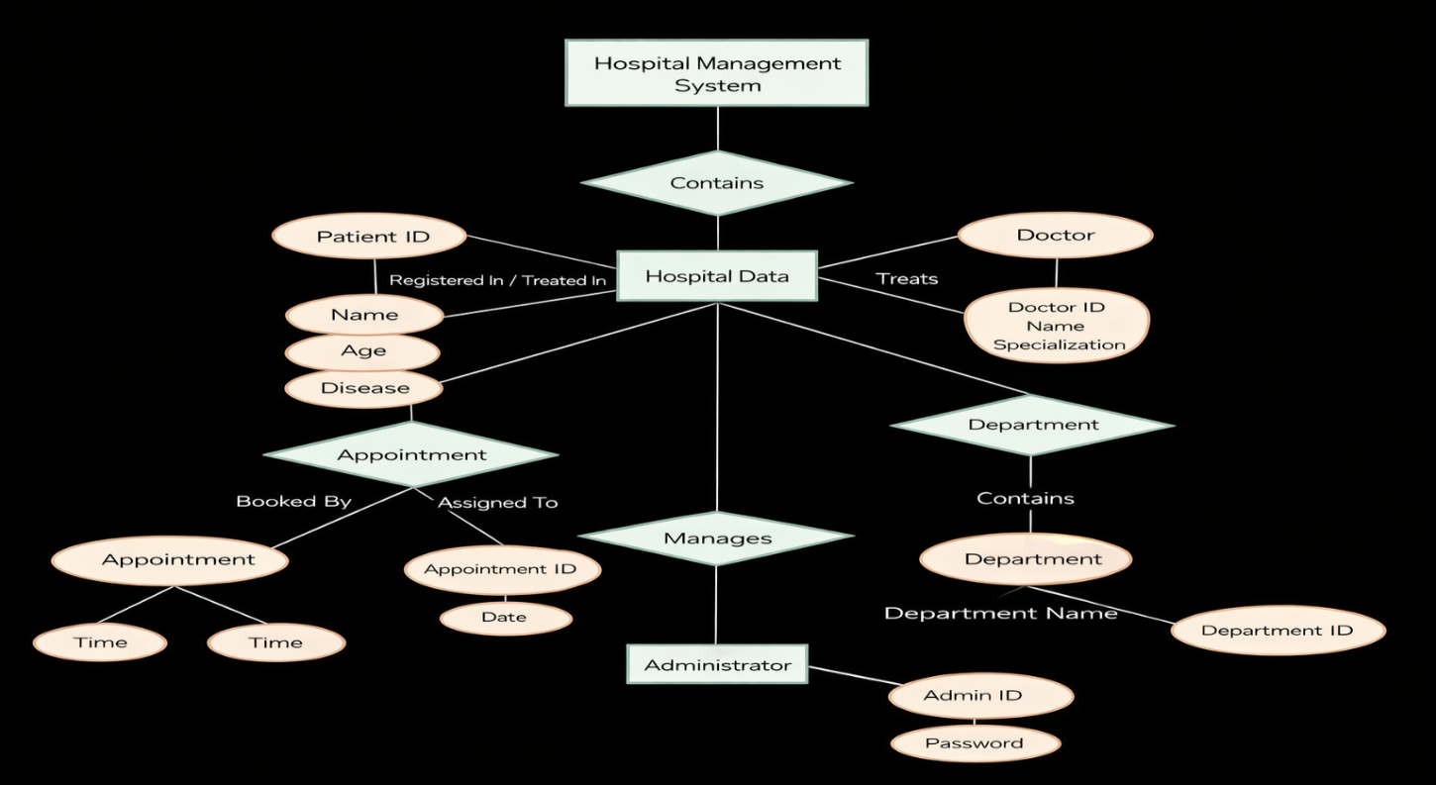


DFD

Level

Level 0 DFD is also called the context diagram and is the least detailed view of the UNICARE Hospital Management System. In this case, the whole system can be represented by one process only, whereas interactions between the system and other processes can be seen. This diagram demonstrates input and output data flow but does not present any processing steps.

External entities interacting with the UNICARE system include: Patient, Doctor, Administrator, and Billing Department. Patient is the source of personal information and appointment request and gets appointment confirmation, prescription, and bill as output. Doctor receives personal information and schedule of appointments as input data and returns prescriptions and diagnoses. Administrator deals with all users of the system and its configuration. Billing department obtains information about treatments and services provided and makes invoices for patients.
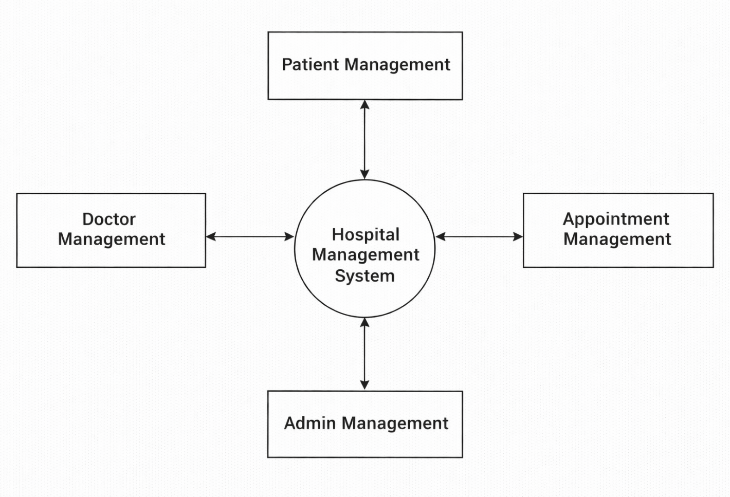



Level

The Level 1 DFD illustrates the decomposition of the process that was depicted in the Context Diagram into a few key subprocesses that are responsible for performing the basic functions of the UNICARE Hospital Management System. The first illustration of the architecture of the system is presented where data exchanges between major processes and data stores become visible.

The following processes are presented at Level 1: (1) User Authentication and Login Management – processes user authentication and login of the Admin, Doctor, Nurse and Patient roles; (2) Patient Registration and Profile Management – stores and retrieves complete profile information about patients; (3) Appointment Scheduling Management – deals with the management of bookings, scheduling and cancellations of appointment time slots; (4) Doctor and Department Management – deals with maintaining doctors' profiles and departments; (5) Billing and Invoice Management – calculates fees and provides billing for patients; and (6) Report Generation – is responsible for producing reports.

At Level 1, the following data stores can be found: (1) Patient database, (2) Doctor database, (3) Appointments database, and (4) Billing database.
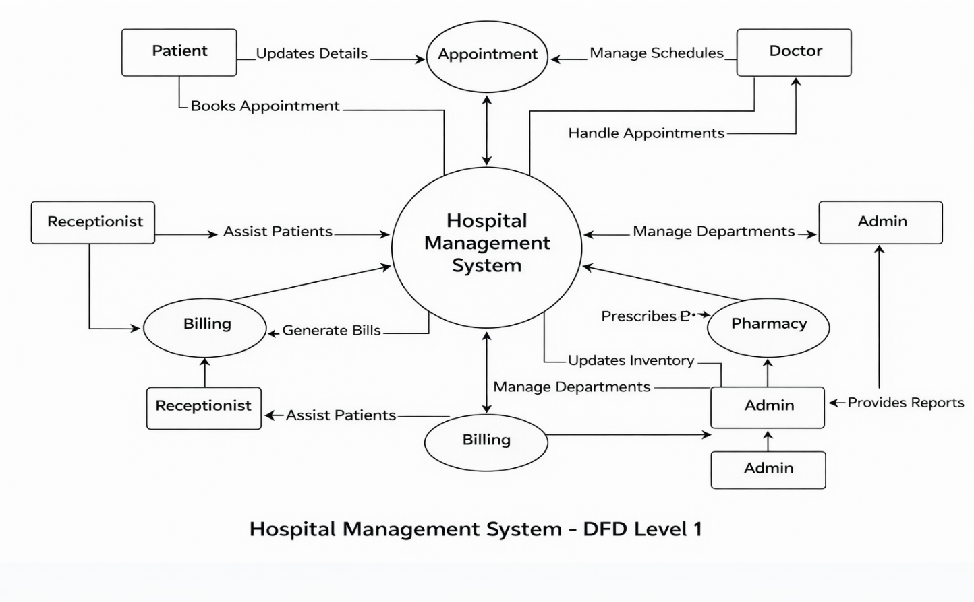


Level

Level 2 DFD gives a further detailed description of all the main processes identified through the Level 1 DFD. In Level 2 DFD, the internal processing activities of each module become apparent through such stages as data validation, data transformations, and data storage.

For instance, the Appointment Scheduling Process in Level 2 DFD would consist of four sub-processes: (a) Check Doctor Availability—this will involve checking the availability of the selected doctor on the desired date and time slot; (b) Verify Patient Information—the information provided by the patient will be checked against the existing records on file; (c) Schedule or Change/Cancels Appointment—an appointment record will be created; and (d) Send Confirmation—a notification or confirmation slip will be sent to the patient.

The Billing Management System is a significant part of the system, and there are many steps involved at Level 2. To start with, the system will collect service details from the Doctor Module, which will contain all the information regarding the treatment provided. Then the system will access charges details from the Fee Master database to ensure that there are no issues with the accuracy of the billing process. After that, the system will compute the bill amount by considering any discounts and insurance deductions. In addition, the system will generate an invoice for the patient. With such an analysis of the system logic, we can see how easy it would be to implement modules based on level 2 DFDs.
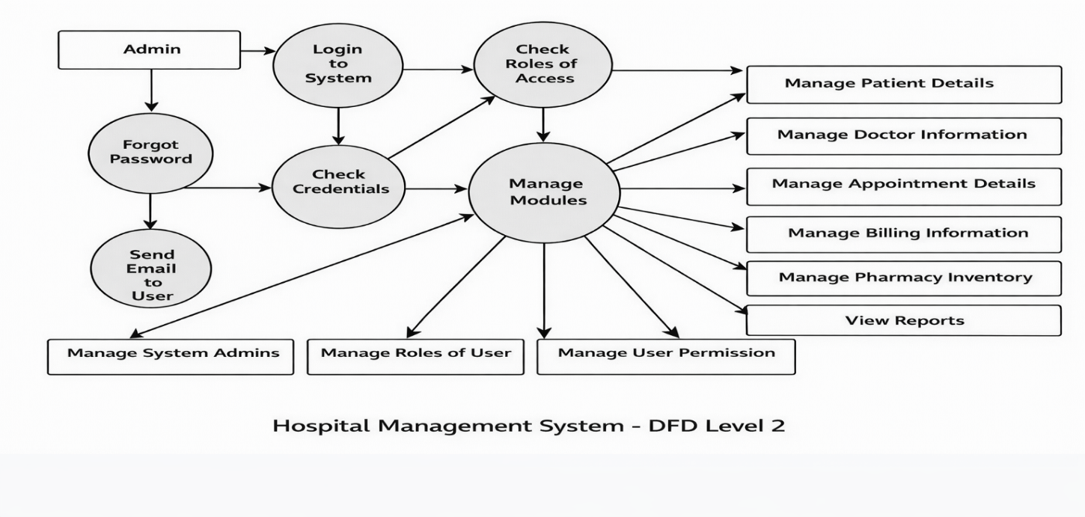


CONCLUSION

UNICARE Hospital Management System is an advanced technology-based system that is aimed at enhancing the way in which hospitals run their daily activities. Through integrating the main functionalities involved, such as patient registration, appointment scheduling, doctor management, billing, wards management, and reporting, the UNICARE system reduces inefficiencies inherent in traditional systems.

Access to sensitive information is granted through a role-based authentication system that ensures only those authorized to do so gain access to information. In the process of managing data, the system makes use of the MySQL relational database that maintains data integrity. Access to this system is through a web-based interface that involves no special hardware and software; it allows access through commonly used browsers, such as Google Chrome, Mozilla Firefox, Microsoft Internet Explorer, and Safari.

The system exhibited immense potential during its planning phase for reducing waiting times, minimizing errors in billing, and facilitating smooth coordination among different departments within the hospital. Some of the possible additions that can be made to the current system in future include telemedicine facility, AI-enabled diagnostics, mobile app interface, and cloud-based deployment for hospitals having multiple branches. On the whole, UNICARE is a trustworthy software solution for healthcare organizations in India.



FUTURE SCOPE

The UNICARE Hospital Management System is versatile and flexible, which allows it to accommodate further improvements and upgrades in the future. In this context, the following aspects may serve as grounds for system development in the coming years:

- Virtual Visits: The system can allow patients to connect with doctors via video conferencing for remote diagnosis, after which doctors can send electronic prescriptions to the patients without requiring any personal contact. This feature is especially important for people from rural or remote locations.
- Mobile Applications: Separate mobile applications for Android and iOS systems may be created for the UNICARE system, which will provide an opportunity for patients to schedule appointments and view their prescriptions using their smartphones.
- Supporting Medical Diagnoses: With help of artificial intelligence and machine learning techniques, the system can provide doctors with assistance in diagnosing patient problems and creating appropriate treatment plans based on past experience.
- EHR compliance: The software can be enhanced to ensure it adheres to international and national electronic health records (EHR) regulations. As such, it can facilitate easy and safe data sharing among healthcare centers, diagnostic centers, and insurance organizations.
- Pharmacy module: An additional module that will facilitate the efficient management of medicines within the hospital, monitoring of expiry dates, and automatic low stocks reorder can be developed.
- Cloud-based deployment and multi-branch support: UniCare can be deployed using the cloud platform. This way, it will be possible to deploy the system in different branches. Hospital administrators will therefore have control over the entire facility from anywhere through real-time updates.
- Patient feedback system: A rating and feedback system can be added so that patients leave reviews after their visits to the hospital.

With these improvements, UNICARE can grow from a system used by one institution to a large, advanced healthcare platform that can serve thousands of patients and medical professionals across the country. This means it can handle a big workload and meet the needs of many people, making it a powerful tool for healthcare.


REFERENCES

- Shortliffe, E. H., & Cimino, J. J. (Eds.). (2021). Biomedical Informatics: Computer Applications in Health Care and Biomedicine (5th ed.). Springer.
- Wager, K. A., Lee, F. W., & Glaser, J. P. (2022). Health Care Information Systems: A Practical Approach for Health Care Management (5th ed.). Jossey-Bass.
- Kumar, V., & Singh, R. (2023). Design and Implementation of a Web-Based Hospital Management System Using PHP and MySQL. International Journal of Computer Applications, 185(12), 34-41.
- Sharma, A., Gupta, P., & Mehta, S. (2024). Role-Based Access Control in Hospital Information Systems: A Security Framework. Journal of Health Informatics, 19(3), 112-128.
- World Health Organization (WHO). (2023). Digital Health Strategy 2020-2025: Strengthen

